Christiaan de wet school
Newsletter / nuusbrief
27 may/mei 2016 nr 3 0f 2016

SPRINGBOKS TO BE
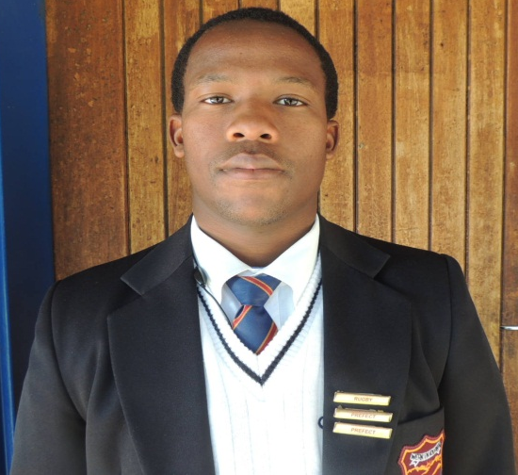

Sechaba Mokhele (left), grade 12, was chosen to play for the Lesotho National Rugby Team. They went on a tournament to Rwanda last week where they played against the Burundi team and won!! We’re proud of Sechaba who is also the captain of the Christiaan de Wet team.
Lukhaya Qithi, (right), grade 10, was selected for the U/16 Southern Free State Rugby Team. Well done, Lukhaya!

FIRST TERM TOP PERFORMER

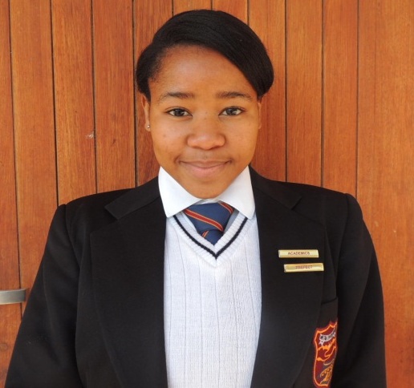
Congratulations to Boitumelo Kose who was the top academic performer in grade 12 for the first term! Ntsebo and Ismaeel are close runners-up. Is it going to stay girl power, Ismaeel? Who is it going to be after the June Exams?

FUN-FILLED SPORT SEASON SO FAR

High School Netball: U/14A – won 1 out of 2 matches
U/15A – won 2 matches out of 3
U/15B – lost their 1 match so far
U/16A – won both their matches
U19A – won 2 of the 4 matches
U19B – lost 2 matches
The U/14 and 16 B-teams did not play league-matches, but thoroughly enjoyed the sports day at Reddersburg and their friendly matches against Koffiefontein and Bloem South.

The First Netball Team girls look quick and chic in their lovely new dresses:
(Thank you, Ms Lizette!)
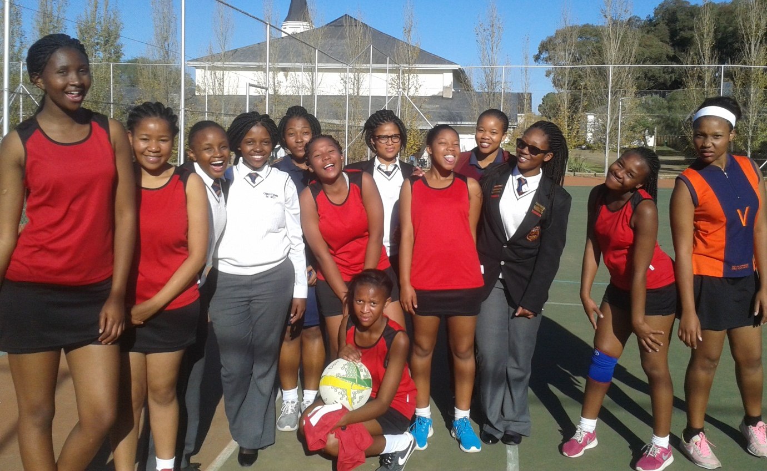

Primary School Netball:

PRIMARY SCHOOL NETBALL
U/10 – Won 2 out of 3 matches
U11 – Won 3 matches and had a tie in the other one
U/12 – Won their one match
U/13 – Won 2 out of 4 matches Well done, Girls!

The RUGBY boys all played three tough matches. The boys are looking forward to the soccer season next term.
READERS AND SPEAKERS THROUGH TO ROUND TWO
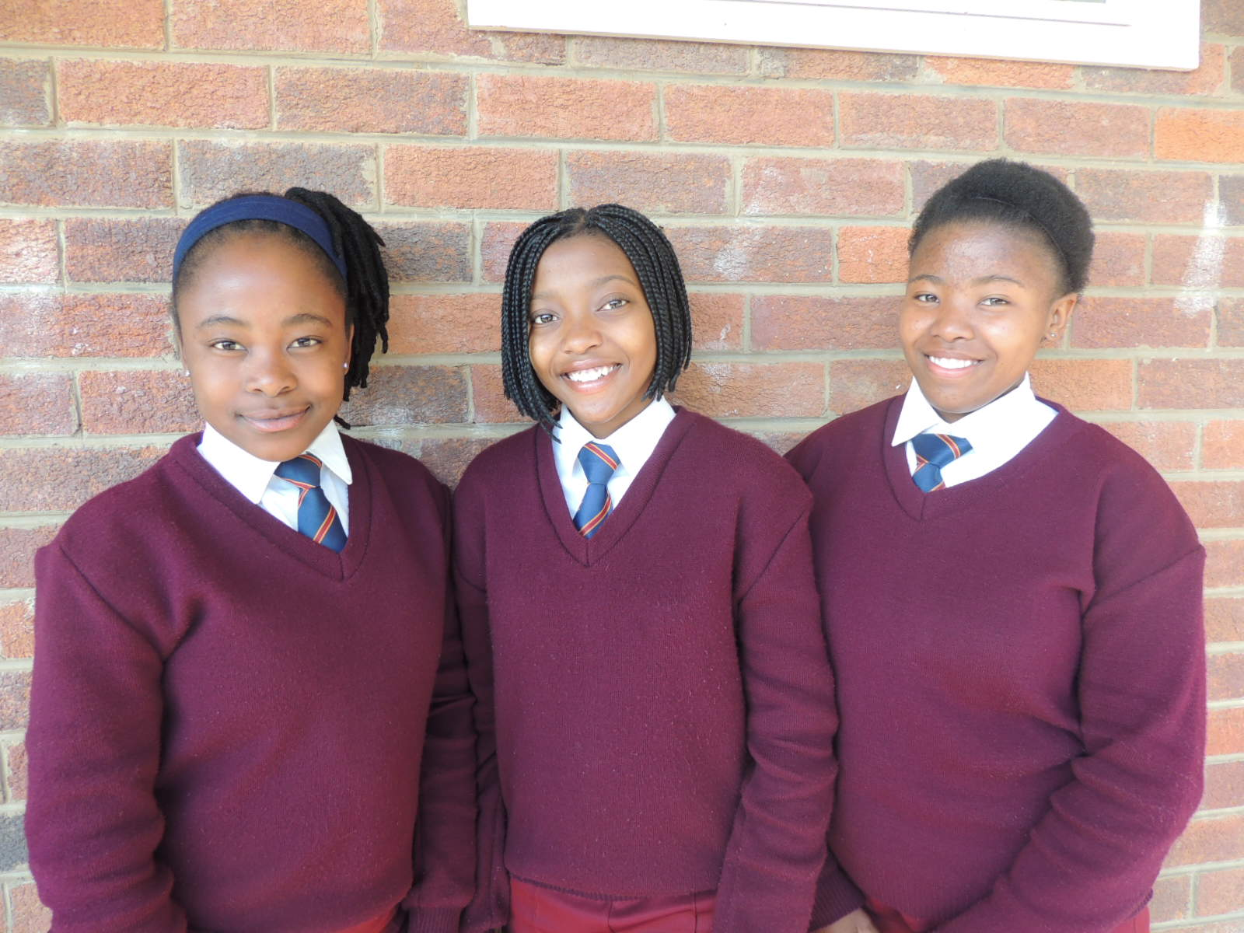

The Free State Department of Sport, Arts and Culture and Recreation organises a reading, speaking and spelling competition through the local libraries, annually. During the first round the above grade 9’s qualified for the district rounds early in July: Tsholofelo Moroe (public speaking), Lelita Xelelo and Paballo Makhanya. The following primary learners went through to the next round: Gr 3: Mohammed Anwary, Relebohile Mangaliso, Reitumetse Pholoana; Gr 4: Keabetswe Ditseho, Leballo Mokhethi; Gr 5: Katleho Molahlehi, Khumo Motlhoioa, Rethabile Putlane; Gr 6: Kekeletso Rantoa and Karabelo Mbena.

IMPORTANT DATES / BELANGRIKE DATUMS

- The school closes on Friday, 24 June at 10:30 / Die skool sluit 24 Junie, 10:30
- The date for the Matric Farewell, third term is: Thursday, 29 September.
- SAVE THE DATE!! A Cultural Day with the theme Diverse Unity to be held on FRIDAY 2 SEPTEMBER 2016 (an out-weekend). We would like ALL our parents to attend that day. The learners are going to perform and the six main different cultures in our school are going to be portrayed. Each will have a food stall with traditional food, wear, crafts, etc. More information will be given through timely.
- AMESA Maths Challenge: Will be written on TUESDAY, 26 JULY 2016. Practice papers will be given to those who have registered.

PANORAMA HOSTEL

Parents are requested to tend to sick children. Many learners are suffering from severe flu. Please take them to the doctor and provide them with the necessary medicine. The hostel cannot provide medicine for serious illnesses.

